**WEB TECHNOLOGY ASSIGNMENT -**

**ATHARVA SHAH, SY-BCA, ROLL NO -60**

Q1. **Write HTML and CSS code to design a web page displaying the following using frameset.**

* **Main.html**

<html>

<frameset rows="10%,*">

    <frame src="top.html">

        <frameset cols="50%,50%">

            <frame src="countries.html">

                <frame name="frame3">

        </frameset>

</frameset>

</html>

* **top.html**

<html>

<h1> IT industries in India </h1>

</html>

* **countries.html**

countries.html

<html>

<body>

    <font color="red">

        <h4>Countries</h4>

        <li><a href="India.html" target="frame3">India</a></li>

        <li><a href="Aus.html" target="frame3">Australia</a></li>

        <li><a href="Japan.html" target="frame3">Japan</a></li>

</body>

</html>

* **India.html**

<html>

<h1>India</h1>

<li>Mumbai</li>

<li>Bangalore</li>

<li>Delhi</li>

</html>

* **Aus.html**

<html>

<h1>City #1</h1>

<li>City #2</li>

<li>City #3</li>

<li>City #3</li>

</html>

* **Japan.html**

<html>

<h1>City #1</h1>

<li>City #2</li>

<li>City #3</li>

<li>City #3</li>

</html>

Output:-

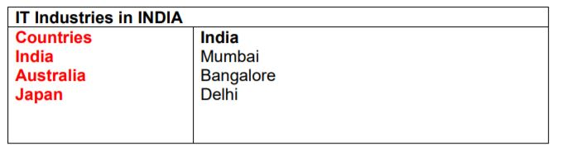

**Q2. Write HTML and CSS code to design a web page displaying list of hyperlinks. Divide the browser screen into two frames. The first frame will display the heading. Divide the second frame into two columns. The frame on the left will be a menu consisting of hyperlinks. Clicking on ‘Pune’ hyperlink it will display related information on the right hand side on the same page.**

* main.html

<!DOCTYPE html>

<html lang="en">

<head>

    <title>QUESTION 2</title>

</head>

<frameset rows="20%,*">

    <frame src="heading.html">

        <frameset cols="30%,*">

            <frame src="link.html">

                <frame name="f3">

        </frameset>

</frameset>

</html>

* heading.html

<!DOCTYPE html>

<html lang="en">

<head>

</head>

<body>

    <h1 style="text-align: center;">IT Industries in INDIA</h1>

</body>

</html>

* link.html

<html>

<body style="background:darkblue; color:white;">

    <h1>City</h1>

    <ol>

        <li><a href="pune.html" target="f3" style="color:white;">Pune</li>

     <li><a href="bangalore.html" target="f3" style="color:white;">Banglore</li>

     <li><a href="hyderabad.html" target="f3" style="color:white;">Hydrabad</li>

     <li><a href="delhi.html" target="f3" style="color:white;">Delhi</li>

   </ol>

 </body>

</html>

* pune.html

<html>

<head>

    <title>Pune</title>

    <style>

        li {

            color: white;

            font-weight: bolder;

            font-size: xx-large;

        }

    </style>

</head>

<body style="background-image: url(https://images.adsttc.com/media/images/51d4/84a8/b3fc/4bea/e100/01d6/large_jpg/Portada.jpg?1372882078); background-position:center center;">

    <h1 style="color:white;">Pune</h1>

    <ul>

        <li>Infosys</li>

        <li>TCS</li>

        <li>Tech-Mahindra</li>

        <li>Persistent</li>

    </ul>

</body>

</html>

* bangalore.html

<html>

<head>

    <title>Bangalore</title>

    <style>

        li {

            color: white;

            font-weight: bolder;

            font-size: xx-large;

        }

    </style>

</head>

<body style="background-image:url(https://i.pinimg.com/originals/5f/a4/d7/5fa4d783842f380b19d15489f0c31cbe.jpg); background-size:500px 500px;">

    <h1 style="color:white;">Banglore</h1>

    <ul>

        <li>Cognizant</li>

        <li>Google</li>

        <li>Microsoft</li>

        <li>Infosys</li>

    </ul>

</body>

</html>

* hyderabad.html

<html>

<head>

    <title>Hyderabad</title>

    <style>

        li {

            color: white;

            font-weight: bolder;

            font-size: xx-large;

        }

    </style>

</head>

<body style="Background-image:url(https://dynamic-media-cdn.tripadvisor.com/media/photo-o/0f/98/f7/df/charminar.jpg?w=900&h=1000&s=1); background-position:center center;">

    <h1 style="color:white;">Hydrabad</h1>

    <ul>

        <li>Capgemini</li>

        <li>Cybage</li>

        <li>Topper</li>

        <li>Cognizant</li>

    </ul>

</body>

</html>

* delhi.html

<html>

<head>

    <title>Delhi</title>

    <style>

        li {

            color: white;

            font-weight: bolder;

            font-size: xx-large;

        }

    </style>

</head>

<body style="Background-image:url(https://www.sustainableplaces.eu/wp-content/uploads/2017/02/SmartBuilding.jpg); background-size:1000px 500px;">

    <h1 style="color:white;">Delhi</h1>

    <ul type=" circle ">

        <li>CHERRY INFOTECH </li>

        <li>Sui-Generis Technologies</li>

        <li>GITS India Solutions </li>

        <li>Infonoble Solutions Pvt Ltd </li>

    </ul>

    </ul>

</body>

</html>

OUTPUT:





**Q3. Write HTML Program to display the following table**

<!DOCTYPE html>

<html lang="en">

<head>

    <title>Table</title>

    <style>

        th,

        td {

            border: 1px solid black;

            padding-right: 50px;

            font-weight: bolder;

        }

        table {

            border-spacing: 0px;

            border: 1px solid black;

        }

    </style>

</head>

<body>

<h1 style="margin-left: 175px;">BMCC PUNE</h1>

    <table>

        <tr>

            <td colspan="2"><center>SPORTS</center></td>

            <td colspan="2"><center>NCC</center></td>

            <td colspan="2"><center>NSS</center></td>

        </tr>

        <tr>

            <td>Boys</td>

            <td>Girls</td>

            <td>Boys</td>

            <td>Girls</td>

            <td>Boys</td>

            <td>Girls</td>

        </tr>

        <tr>

            <td>302</td>

            <td>400</td>

            <td>303</td>

            <td>304</td>

            <td>204</td>

            <td>200</td>

        </tr>

    </table>

</body>

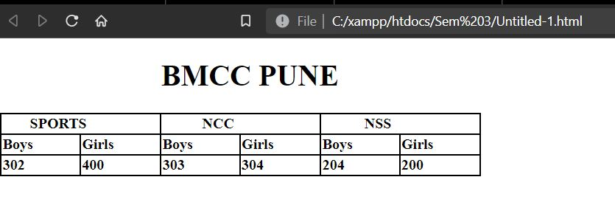</html>

**Q4. Create the following table using HTML:**

<!DOCTYPE html>

<html lang="en">

<head>

    <title>Table</title>

    <style>

        th,

        td {

            border: 1px solid black;

            padding-right: 50px;

            font-weight: bolder;

        }

        table {

            border-spacing: 0px;

            border: 1px solid black;

        }

    </style>

</head>

<body>

    <table>

        <tr>

            <td> QUICK</td>

            <td colspan="2">BROWN FOX

            </td>

            <td>JUMPS</td>

        </tr>

        <tr>

            <td rowspan="3">OVER THE</td>

            <td>LAZY</td>

            <td>DOG</td>

            <td>AND</td>

        </tr>

        <tr>

            <td>THEN</td>

            <td>IT</td>

            <td>FELL</td>

        </tr>

        <tr>

            <td colspan="3">PREY TO A LION</td>

        </tr>

    </table>

</body>

</html>

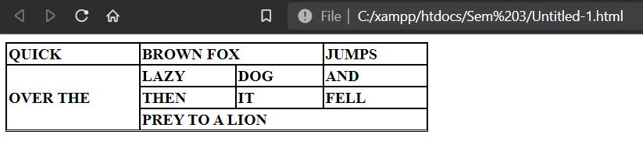

**Q5. Display the following table using HTML:**

<!DOCTYPE html>

<html lang="en">

<head>

    <title>Table</title>

    <style>

        th,

        td {

            border: 1px solid black;

            padding-right: 50px;

            font-weight: bolder;

        }

        table {

            border-spacing: 0px;

            border: 1px solid black;

        }

    </style>

</head>

<body>

    <table border="1">

        <thead>

            <tr>

                <th colspan="3">Invoice #123456789</th>

                <th>14 January 2025

            </tr>

            <tr>

                <td colspan="2">

                    <strong>Pay to:</strong>

                    <br> Acme Billing Co.

                    <br> 123 Main St.

                    <br> Cityville, NA 12345

                </td>

                <td colspan="2">

                    <strong>Customer:</strong>

                    <br> John Smith

                    <br> 321 Willow Way

                    <br> Southeast Northwestershire,

                    <br> MA 54321

                </td>

            </tr>

        </thead>

        <tbody>

            <tr>

                <th>Name / Description</th>

                <th>Qty.</th>

                <th>@</th>

                <th>Cost</th>

            </tr>

            <tr>

                <td>Paperclips</td>

                <td>1000</td>

                <td>0.01</td>

                <td>10.00</td>

            </tr>

            <tr>

                <td>Staples (box)</td>

                <td>100</td>

                <td>1.00</td>

                <td>100.00</td>

            </tr>

        </tbody>

        <tfoot>

            <tr>

                <th colspan="3">Subtotal</th>

                <td> 110.00</td>

            </tr>

            <tr>

                <th colspan="3">Grand Total</th>

                <td>$ 110.00</td>

            </tr>

        </tfoot>

    </table>

</body>

</html>

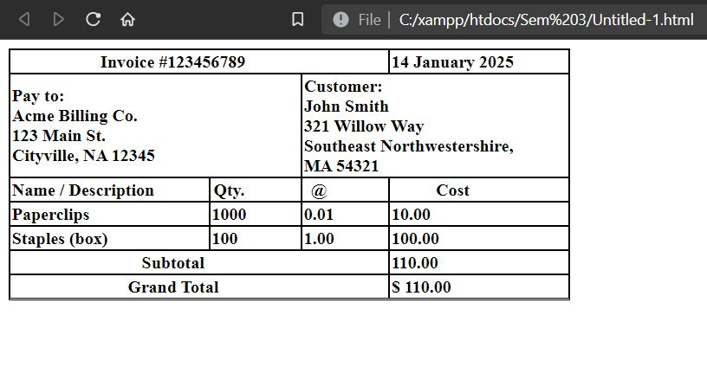

**Q6.** **Write HTML and CSS code to design a web page. Divide the browser screen into two frames. The first frame will display the heading. Divide the second frame into two columns. The frame on the right contains a menu consisting of hyperlinks. Clicking on the first hyperlinks will display related information in a new page as shown below.**

* **main.html**

<!DOCTYPE html>

<html lang="en">

<head>

    <title>QUESTION 4</title>

</head>

<frameset rows="20%,*">

    <frame src="heading.html">

        <frameset cols="30%,*">

            <frame src="link.html">

                <frame name="f3">

        </frameset>

</frameset>

</html>

* **heading.html**

<!DOCTYPE html>

<html lang="en">

<head>

</head>

<body>

    <h1 style="text-align: center;">Home Shopping</h1>

</body>

</html>

* **link.html**

<html>

<body>

    <h1>Home & Kitchen appliances</h1>

    <ul type="square">

        <li><a href="kitchen.html" target="f3">Kitchen & Dining</li>

     <li><a href="furnishing.html" target="f3">Furnishings</li>

     <li><a href="decor.html" target="f3">Home Décor</li>

     <li><a href="improvement.html" target="f3">Home Improvement</li>

   </ul>

 </body>

</html>

* **kitchen.html**

<html>

<head>

    <title>Kitchenware</title>

</head>

<body>

    <h1 style="color:black;">Kitchenware</h1>

    <ol type="i">

        <li>Cookware</li>

        <li>Kitchenware</li>

        <li>Bakeware</li>

        <li>Serveware</li>

    </ol>

</body>

</html>

* **furnishing.html**

<html>

<head>

    <title>Furnishings</title>

</head>

<body>

    <h1 style="color:black;">Furnishings</h1>

    <ol type="i">

        <li>Furnishing #1</li>

        <li>Furnishing #2</li>

        <li>Furnishing #3</li>

        <li>Furnishing #4</li>

    </ol>

</body>

</html>

* **decor.html**

<html>

<head>

    <title>Decor</title>

</head>

<body>

    <h1 style="color:black;">Home Decor</h1>

    <ol type="i">

        <li>Home Decor #1</li>

        <li>Home Decor #2</li>

        <li>Home Decor #3</li>

        <li>Home Decor #4</li>

    </ol>

</body>

</html>

* **improvement.html**

<html>

<head>

    <title>Home Improvements</title>

</head>

<body>

    <h1 style="color:black;">Home Improvements</h1>

    <ol type="i">

        <li>Home Improvement Item #1</li>

        <li>Home Improvement Item #2</li>

        <li>Home Improvement Item #3</li>

        <li>Home Improvement Item #4</li>

    </ol>

</body>

</html>

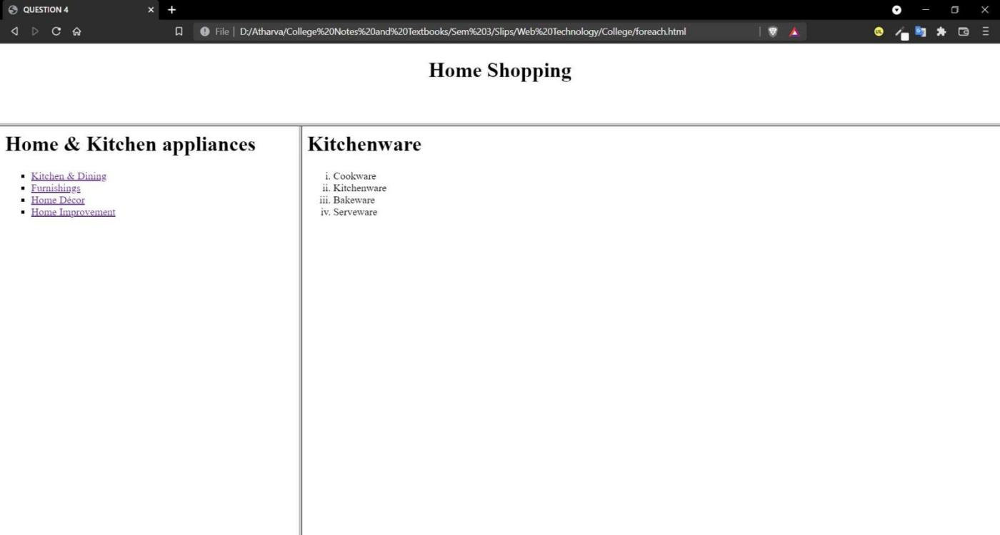**OUTPUT:**

Q7.**Write HTML and CSS code to design a web page. Prepare the following table.**

<!DOCTYPE html>

<html lang="en">

<head>

    <title>QUESTION 1</title>

</head>

<style>

    th,td {

        border: 1px solid black;

        padding: 15px;

        font-weight: bolder;

    }

    table {

        border-spacing: 0px;

        border: 1px solid black;

    }

</style>

<body>

    <h2>F.Y. B.C.A. Exam Time Table</h2>

    <table>

        <tr>

            <th>Date</th>

            <th>Time</th>

            <th>Subject Code</th>

            <th>Subject Name</th>

        </tr>

        <tr>

            <td>12/10/2015</td>

            <td>5 10:30 am – 1:30pm </td>

            <td>101</td>

            <td>PPA</td>

        </tr>

        <tr>

            <td>13/10/2015</td>

            <td>10:30 am – 1:30pm</td>

            <td>102</td>

            <td>MOE</td>

        </tr>

        <tr>

            <td>14/10/2015 </td>

            <td>10:30 am – 1:30pm</td>

            <td>103</td>

            <td>BC</td>

        </tr>

        <tr>

            <td>15/10/2015</td>

            <td>10:30 am – 1:30pm</td>

            <td>104</td>

            <td>PM</td>

        </tr>

        <tr>

            <td>16/10/2015 </td>

            <td>10:30 am – 1:30pm</td>

            <td>105</td>

            <td>FA</td>

        </tr>

    </table>

</body>

OUTPUT:

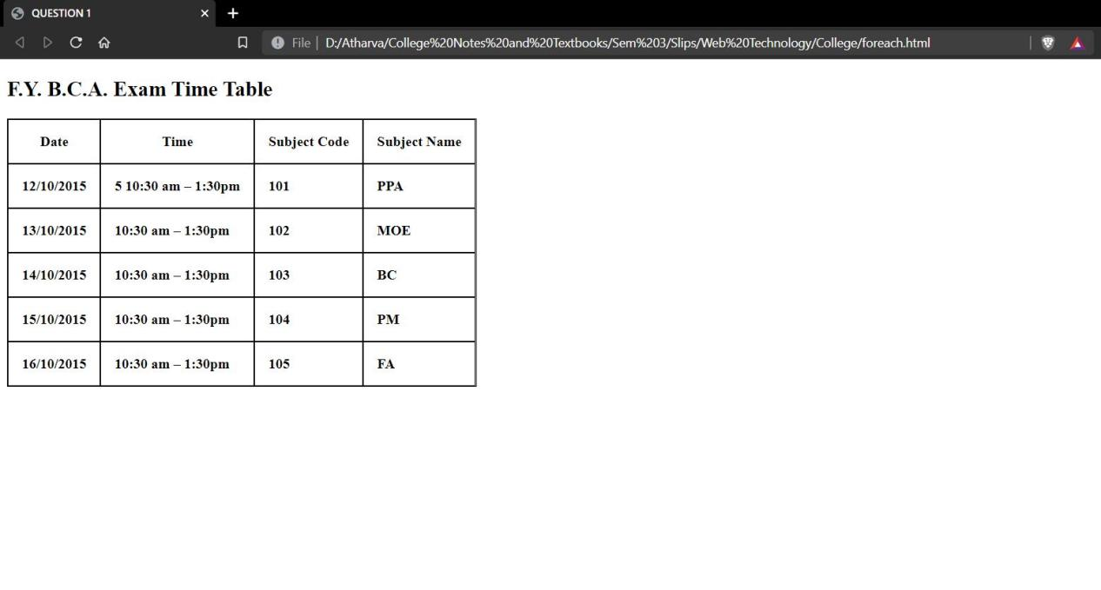

Programs performed by Atharva Shah